|  |  |  |  |  |
| --- | --- | --- | --- | --- |
|  | | | | |
|  |  |  | |  |
| QUANTIUM VIRTUAL INTERNSHIP  TASK 1 | | |
| JOEL DOMINGO | | Joeldomingo117@gmail.com |

|  |
| --- |
|  |
| summary of code / insights fOR RAW CODE: PROCEED TO PAGE 20Number of Transactions Over FY18-19 We see a large increase in sales building up to Christmas, and a sudden drop off afterwards back to the regular amount. The data does not include the drop to 0 sales on Christmas day due to closure on the 25th of December.  The data shows no significant outliers besides December sales, which is already explained by the lead up to the Christmas period. | |
| Packet Size Analysis The smallest packet is 70g, whilst the upper range goes up to 380g packets. The most common packet purchased is 175g. We see a common pattern with the distribution, with 110g, 134g, 150g and 175g topping the purchases. This may be an indication that consumers see these sizes as being the best value for the price. In the figure below, we see that the upper ranges of the packet sizes are not as popular as those stated above, in fact they are significantly lower in popularity. | |

|  |  |  |
| --- | --- | --- |
|  | |  |
| Brand Analysis Kettle is the most popular brand of chips, followed by Smiths. Doritos and Pringles are relatively equal in terms of popularity, while Burger Rings and French Fries are the least popular brand of snacks.   Customer Segments - Life stage The business categorizes customer life stage segments into 7 classes. Most customers are either retirees or older/younger singles/couples, being 20.4%, 20.1% and 19.9% respectively, making up 60.4% of the total customer population. | | |
|  |
|  |
| Customer Segments - Life stage (Purchasing Behavior) The number of transactions by each lifestage closely follows the population distribution of that segment. In terms of expenditure, all segments spend a very similar amount (+$7), with only slight deviation of each other. Older singles/couples spend the most money on snacks, followed by Retirees and Older Families. Regarding quantities per transaction, all segments average between 1.75 to 2 chip packets per transaction. Older families have bought the most, with new families the least. For all subsets, the average price of each unit sold for all subsets are all between $3.7 and $3.9.           Customer Segments - Life stage (Favorite Brands) For all lifestage customer segments, the top 5 brands appear to be the same. The top to brands per segment are Kettle and Smiths, followed by either Doritos or Pringles.             Customer Segments – Premium or Type There are 3 Customer Premium Types:   * Mainstream * Budget * Premium   Mainstream makes up majority of customers. | | |  |

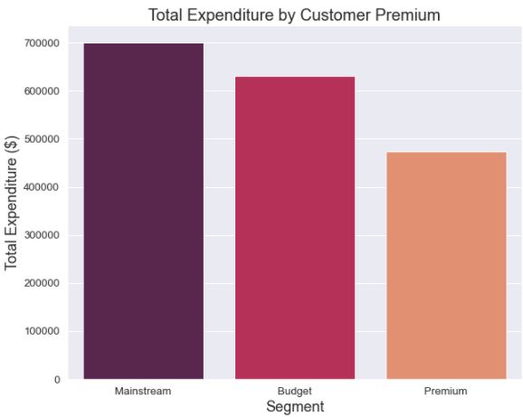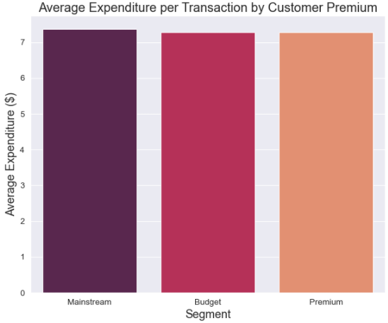

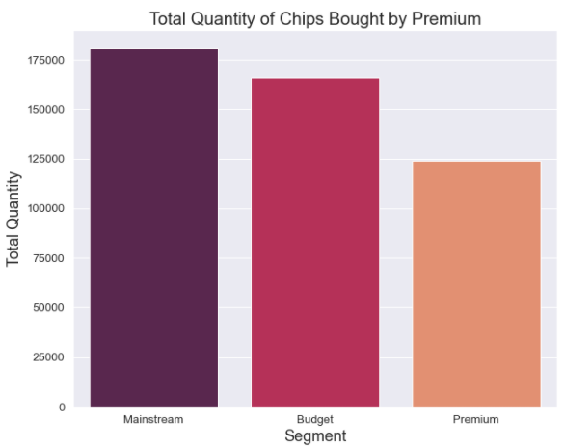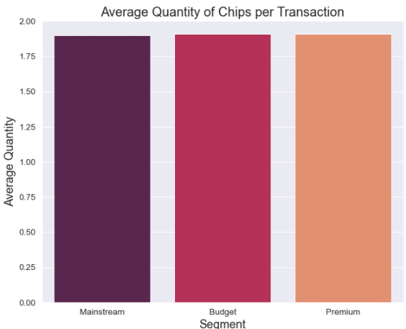  
  
  
  
  
  
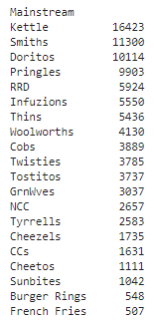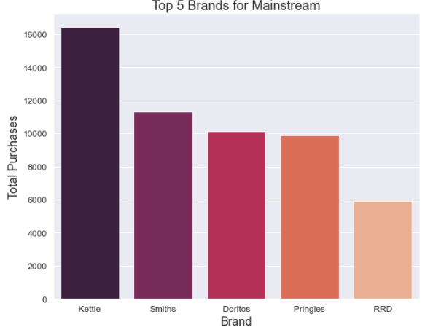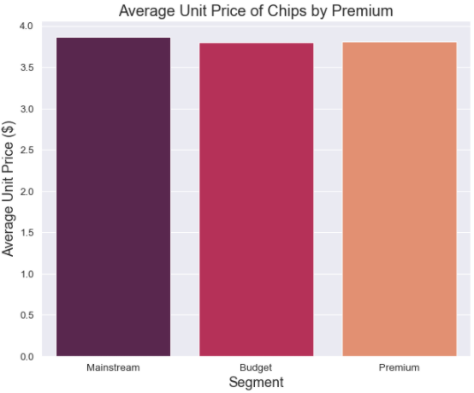D

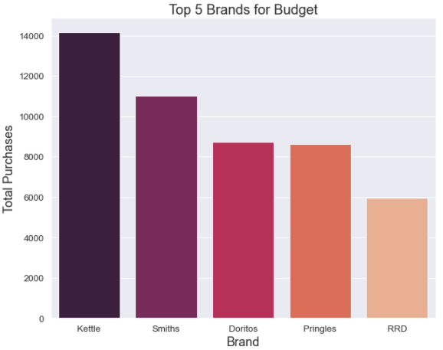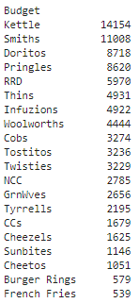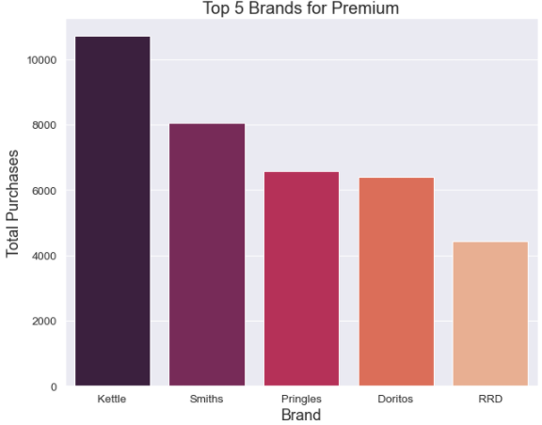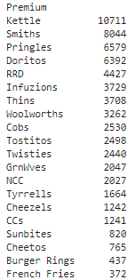

## OBSERVATIONS (CUSTMOMER PREMIUM TOP BRANDS)

For all customer premium segments, the top 5 brands are all homogeneous, including order. The only observable difference is slight variation between ranks 3 & 4 (Doritos and pringles), and 5 & 6 (RRD and Infuzions).

## Customer Segments – Proportion of Lifestage Segments within Premium Segments

The following charts illustrate the proportion of lifestage segments make up the customer premium segments, and visa versa.

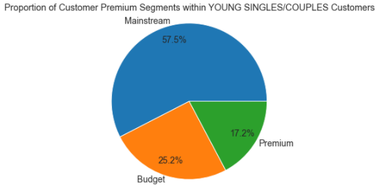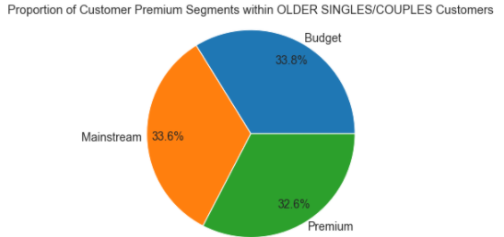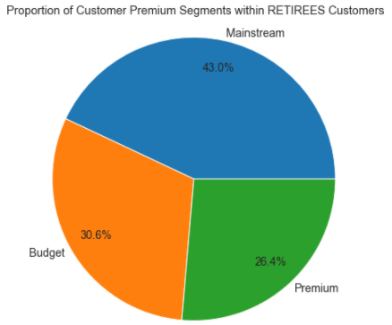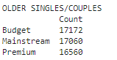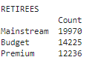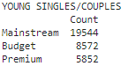

|  |  |
| --- | --- |
|  |  |
|  | |

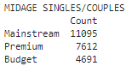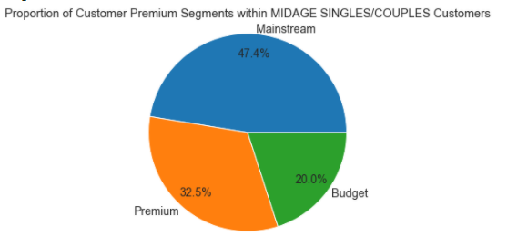

|  |  |
| --- | --- |
|  |  |
|  | |

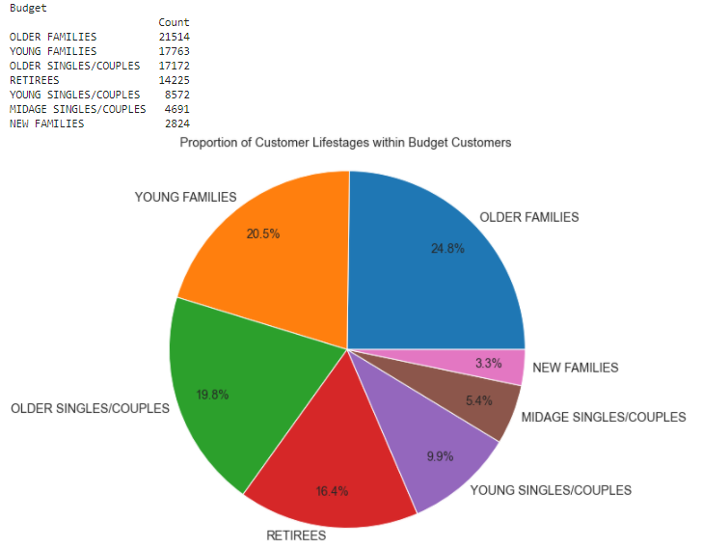

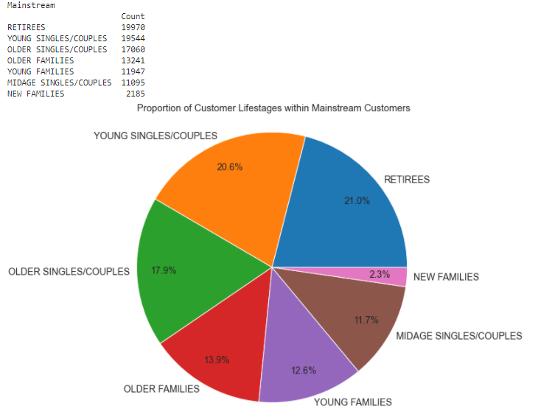

|  |  |
| --- | --- |
|  |  |

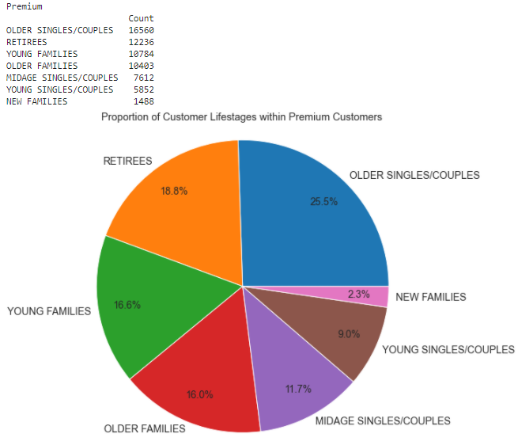

The We can further dive into their purchasing behavior by looking at their average unit price per transaction.

## Customer Segments – Average Unit Price Analysis Per Lifestage

Looking at the data, we see that younger singles/couples and new families are more willing to spend on more premium ranges of snacks.

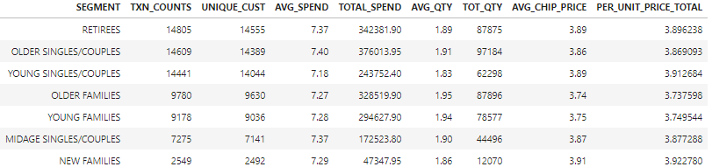

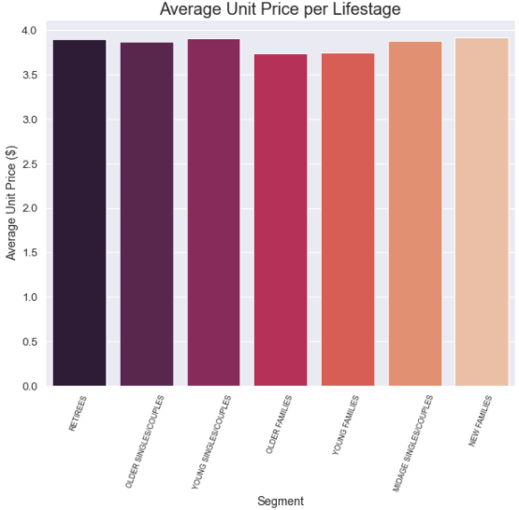

## Customer Segments – Average Unit Price Analysis Per Premium

Looking at the data, we see that Mainstream customers are more willing to spend on more premium ranges of snacks.

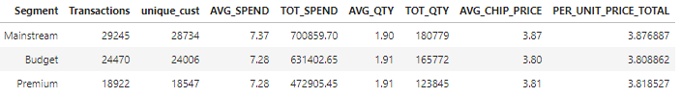

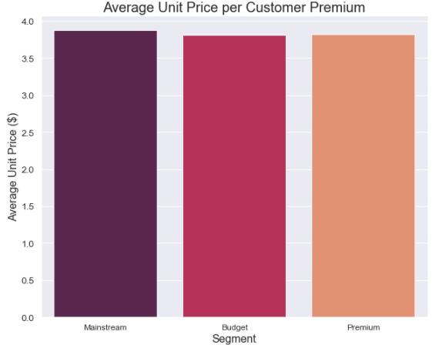

## Total Observations: Average Unit Price

Based on the data shown, young singles/couples who are registered as the mainstream premiums are willing to pay more per unit compared to other segments. Reasons for this could lie with a more health-oriented purchasing behavior. This is further backed up by there being fewer purchases by premium middle-aged and young singles/couples’ customers, compared to mainstream segments of the same kind.

We must check if this difference in unit price is statistically significant for these segments. We can do this by performing a t-test of significance.

## T-Test: Average Unit Price

The following distributions show the distribution for Mainstream young and middle-aged singles/couples compared to other premiums of the same lifestage. When performing the t test, we get a p-value of **0.015** (with our limit being 0.05). This suggests that the unit price for mainstream, young and middle-aged singles and couples are significantly higher than that of budget or premium segments of the same lifestage.

**T-Test Results:**

|  |  |
| --- | --- |
| **Statistics** | 2.445 |
| **p-value** | 0.015 |
| **Result** | Different distributions (reject h0) |

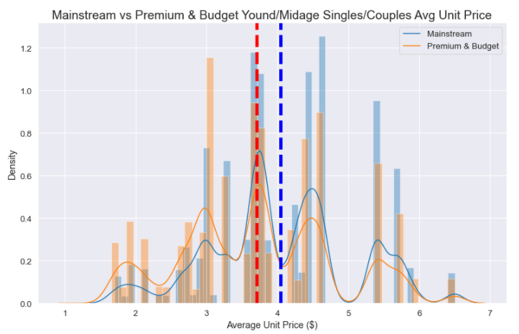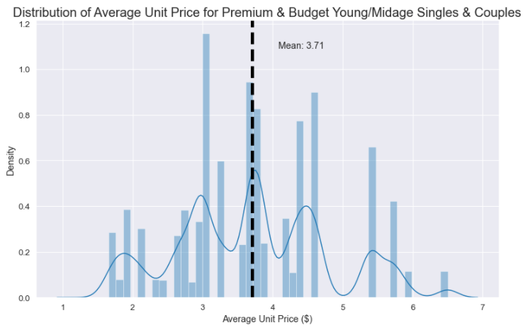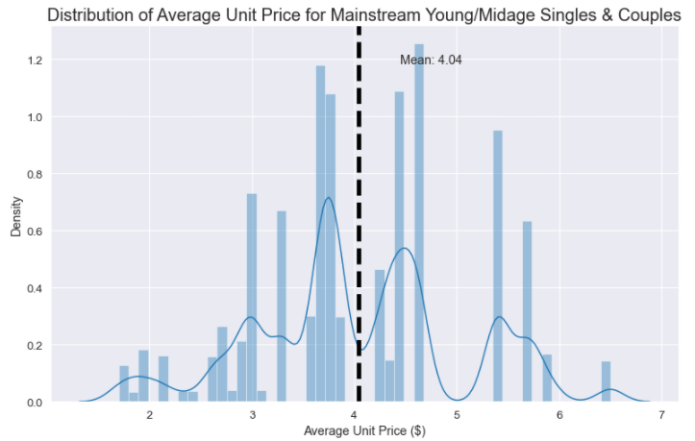

## Further Insights: Total Expenditure

When looking at the total expenditure by each individual segment, the highest paying segments include:

* Older Families with Budget Premiums
* Young singles/couples with Mainstream Premiums
* Retirees with Mainstream Premiums

**Recommendations:**

* Target segments which provide the most sales.
* Cater to these segments will further increase sales. We can do this by looking at their favorite brands of snacks.

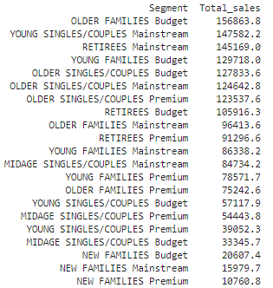

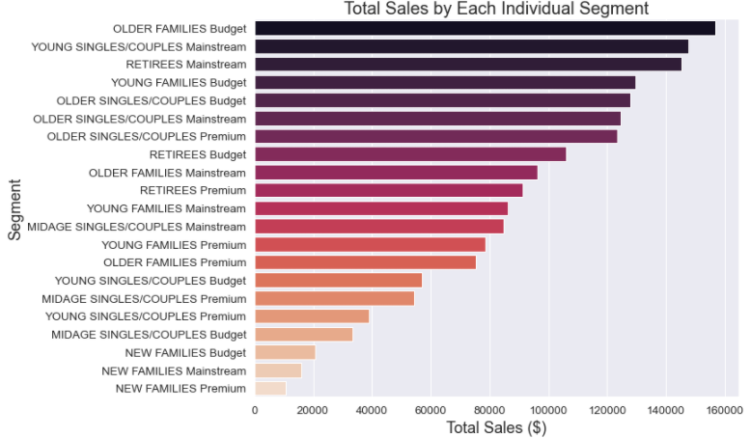

## Further Insights: Top Brands by Top Spending Segments

Based on the expenditure analysis, the top 3 segments have the following favorite brands:

|  |  |  |  |
| --- | --- | --- | --- |
|  | **Older Families | Budget** | **Young Singles/Couples | Mainstream** | **Retirees | Mainstream** |
| **1.** | Kettle | Kettle | Kettle |
| **2.** | Smiths | Smiths | Smiths |
| **3.** | Doritos | Doritos | Pringles |
| **4.** | Pringles | Pringles | Doritos |
| **5.** | Red Rock Deli | Red Rock Deli | Red Rock Deli |

**Recommendations:** Run promotions on these brands to attract higher sales quantities.

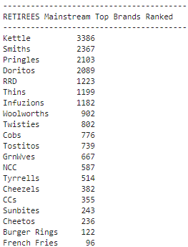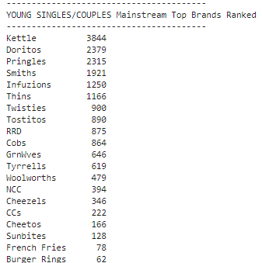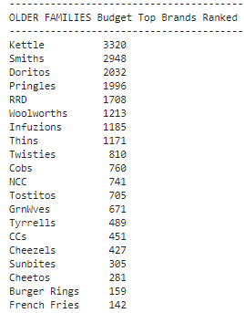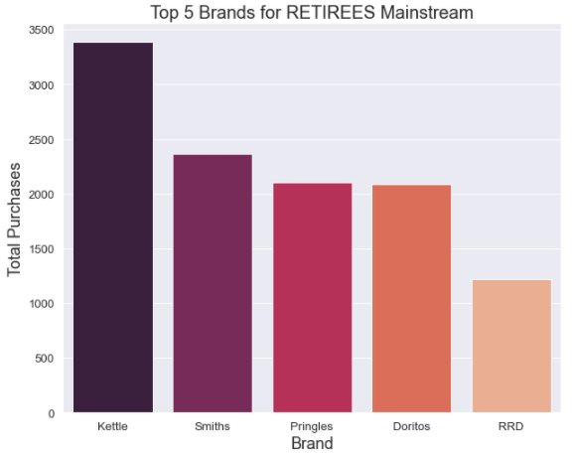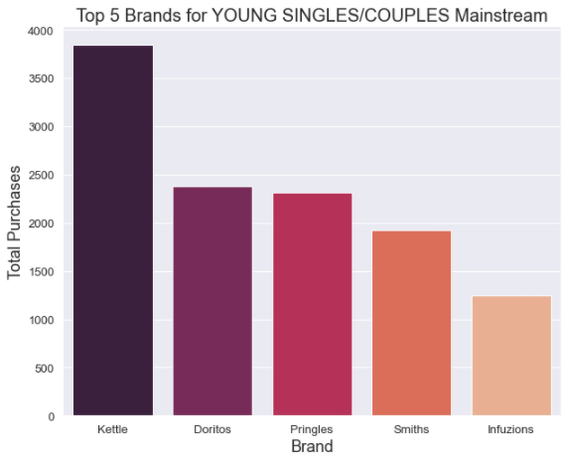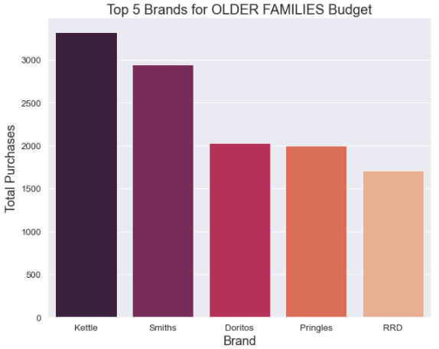 ­­

**Further Insights: Top Unit Sizes per Top Spending Segments**

Across the top spending segments, we want to look at the most popular pack sizes. This will give an idea on how to handle stock management.

Across the top 3 segments, the most popular pack sizes are homogeneous. The sizes are:

|  |  |  |  |
| --- | --- | --- | --- |
|  | **Older Families | Budget** | **Young Singles/Couples | Mainstream** | **Retirees | Mainstream** |
| **1.** | 175g | 175g | 175g |
| **2.** | 150g | 150g | 150g |
| **3.** | 134g | 134g | 134g |

**Recommendations:** Prioritize these sizes when replenishing stock and negotiating with suppliers.

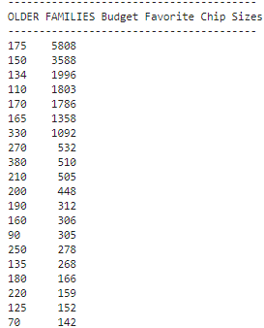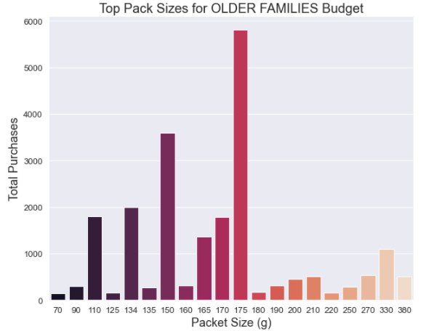

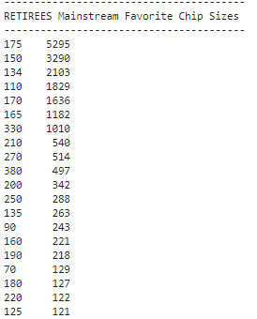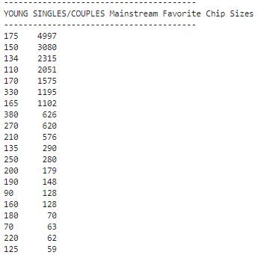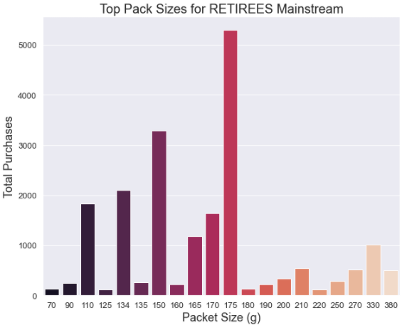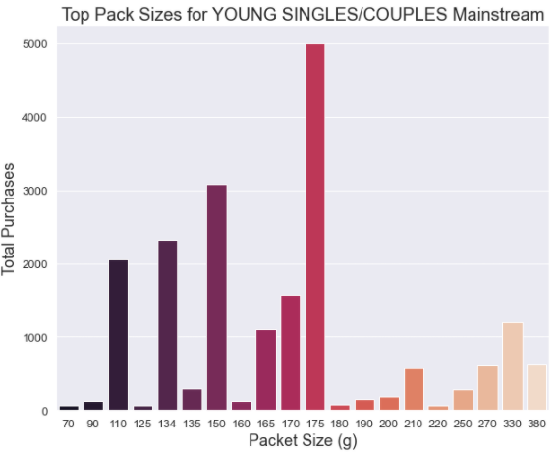

# Project code (jupyter notebook)

## Language Used: Python & SQL